January 28, 2018

Dear Friends,

You are hereby invited to attend the 2018 AFA-NIET District One “Last Chance” Tournament and NIET Qualifier swing. This year’s swing will be held at San Francisco State University in San Francisco, CA, from March 3-4, 2018. The District’s “Last Chance” (March 3, 2018) Tournament is open to all schools, while the District’s Qualifier Tournament (March 4, 2018) is only open to those schools that can subscribe in District One. The deadline to enter both tournaments is TUESDAY, FEBRUARY 23 at 6:00 PM. Please enter online at http://www.forensicstournament.net.

This year’s NIET will be held at the Colorado College, Colorado Springs, CO on April 6-9, 2018. Please note that this is a Saturday-Monday schedule with registration on Friday. An invitation is available online at http://www.afa-niet.org. If you have students who have qualified at-large for the NIET, you will need to submit an at-large qualification form for each student by Thursday, March 1, 2018. ALL QUAL SHEETS SHOULD BE E- MAILED to me, your District Chair, at yaw.kyeremateng@cui.edu. Please submit any results from a tournament not available on forensicstournament.net with your verification forms. At-large verification sheets are attached with the invitation so you may email me (via attachment) for greater convenience. Please get forms to me as soon as possible so that I can verify that your student is qualified for the NIET. The official deadline to earn legs is March 12, but I need forms well before that to verify them.

You are encouraged to nominate up to 2 students from your school for the AFA-NIET All American Award. Please see inside the invitation for forms and more information. All nomination materials must be turned in to me no later than Sunday afternoon, March 4, 2018, at the Coaches’ Meeting. We cannot consider incomplete files; do make plans to have the application, competition and service résumés, recommendation letters, as well as official transcripts ready by the deadline.

If you have any questions about the At-Large qualification process, or the NIET, please feel free to contact me at yaw.kyeremateng@cui.edu. Please let me know if you have any questions about the tournaments, and we look forward to seeing you in Northridge

Sincerely,

Yaw Kyeremateng
District I Chair
562-374-3250
yaw.kyeremateng@cui.edu
Theodore Albiniak
Tournament Host
415-338-1597
Albiniak@sfsu.edu

SCHEDULES
**Schedule will be adjusted as necessary depending on number of entries**
District One “Last Chance” Tournament

Saturday, March 3, 2018
7:00-8:00AM | Registration (Humanities 290)
7:45 AM | Extemp Draw
8:00 AM | Round 1A  Round 1: ADS, DUO, PER, POE, POI
8:15 AM | Round 1A Extemp  Round 1: EXT
9:30 AM | Extemp Draw
9:45 AM | Round 2A  Round 2: ADS, DUO, PER, POE, POI
10:00 AM | Round 2A Extemp
11:15 AM | Round 1B  Round 1: CA, DI, IMP, INF, PRO
12:30 PM | Lunch
1:30 PM | Round 2B  Round 2: CA, DI, IMP, INF, PRO
2:45 PM | Extemp Draw Final
3:00 PM | Finals Group A  Final round: ADS, DUO, PER, POE, POI
3:15 PM | Extemp Final  Final round: EXT
4:30 PM | Finals Group B  Final round: CA, DI, IMP, INF, PRO
6:00pm or ASAP | Awards Ceremony

District One Qualifier Tournament
Sunday, March 4, 2018
7:00-8:00AM | Registration (Humanities 290)
7:45 AM | Extemp Draw  Prep: EXT
8:00 AM | Round 1A  Round 1: ADS, DUO, PER, POE, POI
8:15 AM | Round 1A Extemp  Round 1: EXT
9:30 AM | Extemp Draw  Prep: EXT
9:45 AM | Round 2A  Round 2: ADS, DUO, PER, POE, POI
10:00 AM | Round 2A Extemp  Round 2: EXT
11:15 AM | Round 1B  Round 1: CA, DI, IMP, INF, PRO
12:45 PM | Round 2B  Round 2: CA, DI, IMP, INF, PRO
2:00-3:00 PM | Student/Coaches meeting
3:15 PM | Extemp Draw Final  Prep: EXT
3:30 PM | Finals Group A  Final round: ADS, DUO, PER, POE, POI
3:45 PM | Extemp Final  Final round: EXT
4:45 PM | Finals Group B  Final round: CA, DI, IMP, INF, PRO
6:15pm or ASAP | Awards Ceremony

RULES, REGULATIONS AND PROCEDURES

DISTRICT ONE “LAST CHANCE” REGULATIONS
- Open to all schools.
- Students may enter up to 3 events. Extemporaneous competitors may only double enter.
- Each judge covers 5 slots total.
- We reserve the right to limit entry based on judge availability. Please enter student’s events in the order of preference. We will take each student’s first event, then second, and then 3rd if there are enough rooms/judges.
- We will abide by AFA-NIET rules for the tournament.

DISTRICT ONE NIET QUALIFIER REGULATIONS
- Each school may enter up to five slots in each event.
- Students may not enter events that they have already qualified. Students whose school is not planning on attending the NIET may not enter.
- We will be going by the two pattern system, two rounds, with 2 judges per prelim round (If we have enough judges. If not, we will fall to 1 judge per prelim round)
- Because we will be going by the two pattern system, students may triple-enter
- Each judge covers 5 slots per pattern.
- We will abide by AFA-NIET rules and the district charter for the tournament.

WHERE TO SEND AT-LARGE SHEETS AND TOURNAMENT ENTRY
Please enter online at http://forensicstournament.net.

The deadline is TUESDAY, FEBRUARY 27, 2018 at 6:00 PM. You may make changes up until Wednesday, February 28, 2018 at Noon, when fees will be assessed. If you have problems with the online entry system, please email Yaw Kyeremateng, or call him at his office at 562-374-3250. For At-Large entry forms, please email me via an attachment to yaw.kyeremateng@cui.edu

FEE INFORMATION

“LAST CHANCE”
School Fee: $20
Cost per slot at the “Last Chance” Tournament: $5 ($10 for Duo)
Judging fee per uncovered slot: $15 (One judge covers 5 slots)
$15.00 per change after Tuesday, February 27, 2018 at Noon
$100.00 dropped judge fee after Tuesday, February 28, 2018 at Noon

DISTRICTS
NIET Subscription Fee (if not already paid): $50
Per School Judge Fee (passed 3/2006 meeting): $50
Cost per slot at the Qualifier Tournament: $8 ($16 for Duo)
Judging fee per uncovered slot: $15 (One judge covers 5 slots per pattern)
$15.00 per change after Tuesday, February 27, 2018 at Noon
$100.00 dropped judge fee after Tuesday, February 27, 2018 at Noon

Please bring CASH to pay your fees or contact Yaw Kyeremateng to get information on who the check needs to be made out to. Yaw can be reached via email at Yaw.kyeremateng@cui.edu and via phone at (562) 374-3250.

We love your judges more than your money so please bring judges to cover your slots.

LODGING

There is still no central tournament hotel; but there are several good options.

HOTEL INFORMATION
Most of these hotels offer double bed rooms (quad occupancy) in the $95-$150 price range, which is about the cheapest range for this area. Priceline, kayak, and other online hotel reservation sites may offer cheaper prices than if you call these hotels.

Hampton Inn – Daly City
2700 Junipero Serra Boulevard
Daly City, CA 94015
(650) 755-7500
www.hamptoninn.com
~ 3 miles from campus, a 10-minute drive with no traffic

El Camino Inn
7525 Mission Street
Daly City, CA 94014-2941
(650) 755-8667
www.elcaminoinn.com
~ 3 miles from campus, a 10-minute drive with no traffic

Alpine Inn & Suites
560 Carter Street
Daly City, CA 94014
(415) 334-6969
alpinemotorinn.com
~5 miles from campus, a 15-minute drive with no traffic
Hyatt Regency San Francisco Airport
1333 Bayshore Highway
Burlingame, California, USA 94010
(650) 347-1234
www.sanfranciscoairport.hyatt.com
~13 miles from campus, a 20-minute drive with no traffic

Best Western Grosvenor Airport Hotel
380 South Airport Blvd
South San Francisco, CA 94080
(650) 873-3200
www.grosvenorsfo.com
~10 miles from campus, a 15-minute drive with no traffic

Comfort Inn & Suites - Airport
121 East Grand Avenue
South San Francisco, CA 94080
(650) 589-7100
www.sfosuites.com
~10 miles from campus, a 15-minute drive with no traffic

Regardless of where you choose to stay, you are encouraged to make your reservations as soon as possible. If you have any questions about lodging, please contact Teddy Albiniak at Albiniak@sfsu.edu

DIRECTIONS

The ballot table, Tab room, food & beverages, and all central activities will be held in the Humanities building on the SF State campus, most easily accessed on Tapia St. between Holloway Ave. and Font Blvd.

From Daly City/South SF/Airport area:
Take 280 North
Follow signs for 1 North towards SFSU and the Golden Gate Bridge
Continue on Junipero Serra Blvd. (slight right)
Left on Holloway Ave.
Right on Tapia Dr.

From North Bay
Take 101 South across GG Bridge
Follow signs for 19th Ave.
Right onto Holloway Ave.
Right onto Tapia Dr.

From East Bay
Take 80 West across Bay Bridge
Follow signs to 101 South
Take exit to 280 South
Take the CA-82 N/San Jose Ave. exit toward CA-1 N/Mission St.
Slight right at the first stoplight onto Sagamore
Stay in right lane and follow onto Brotherhood Way
Take the Junipero Serra Blvd. N/CA-1 N ramp to SF State University
Continue on Junipero Serra Blvd. (slight right)
Left on Holloway Ave.
Right on Tapia Dr.

PARKING

Parking is available in the parking structure on campus, for $7 per car per day. Be sure to clearly display the permit on the dash of your car. Continue down Holloway to Lake Merced, and turn right to reach parking structure.

There is also some street parking. Be sure to check if it is 1-hour, 2-hour, 4-hour, or unlimited parking, and move your vehicle accordingly.

We are friendly with campus police, but will not be able to do anything about your parking tickets. Be vigilant! Also SFSU is a smoke-free campus. Please be respectful.

MAP

Link to full campus map: http://www.sfsu.edu/~sfsumap/

Southwest quadraint and tournament site:

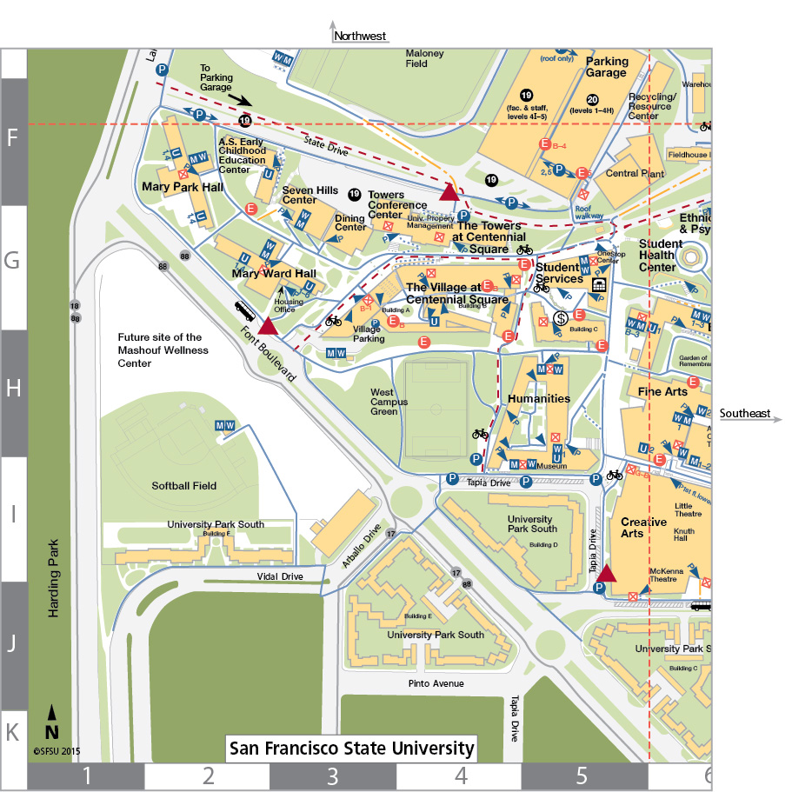


At Large Reporting Form

FORM MUST BE IN THE HANDS OF YOUR DISTRICT CHAIR BY MARCH 12, 2013

STUDENT: ___________________________________________ (fill out one form for each student)
SCHOOL: ____________________________________________
COACH: ______________________ Office Phone: __________________ Home Phone: __________
_______
 | Event | Rank | Tournament | Date | # of  Schools | # of entries
GROUP A EVENTS: Informative/Prose/Impromptu
1st event in "A" | . | , | , , ZXZZXZZ | , | , | ,
1st event in "A" | , | , | . . | . | . | .
1st event in "A" | . | . | . . | . | . | .
2nd event in "A" | . | . | .. | . | . | .
2nd event in "A" | . | . | .. | . | . | .
2nd event in "A" | . | . | .. | . | . | .
GROUP B EVENTS: Extemporaneous/Dramatic Duo/Persuasion/Program Oral Interpretation
1st event in "B" | . | . | .. .. | . | . | .
1st event in "B" | . | . | . . | . | . | .
1st event in "B" | . | . | . . | . | . | .
2nd event in "B" | . | . | .. | . | . | .
2nd event in "B" | . | . | ... | . | . | .
2nd event in "B" | . | . | .. | . | . | .
.
GROUP C EVENTS: Poetry/Communication Analysis/After Dinner Speaking/Interpretation of Drama
1st event in "C" | . | . | . . | .. | . | .
1st event in "C" | . | . | . . | . | . | .
1st event in "C" | . | . | .. | . | . | .
2nd event in "C" | . | . | .. | .. | .. | .
2nd event in "C" | . | . | .. | . | . | .
2nd event in "C" | . | . | . | . | . | .
Send completed form to your District Chair
DO NOT SEND FORM TO THE NATONAL TOURNAMENT DIRECTOR

FORM MUST BE IN THE HANDS OF YOUR DISTRICT CHAIR BY MARCH 12, 2016

I certify the above information is correct and meets requirements for AFA-NIET At-Large Qualification

COACH’S SIGNATURE:____________________________________________________________________

